*Pizza store analysis*

*We were askes to extract some insights from the data provided by the client*

*Firstly we will start with the KPI cards.*

* *Total revenue :*

*By using this query we calculated the total revenue of the store*

select sum(total_price) as total_revnue from pizza_sales ;

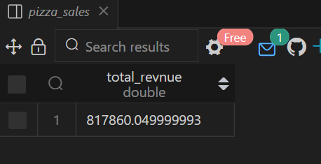

* *Average amount of each order*

select sum(total_price)/ COUNT(DISTINCT order_id) as  average_order_value FROM pizza_sales;

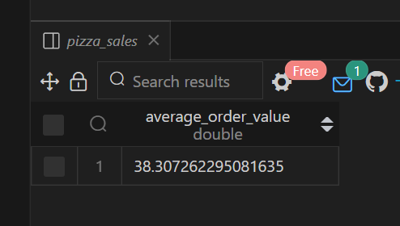

* *Number of pizza sold:*

SELECT SUM(quantity) as total_pizza_sold from pizza_sales;

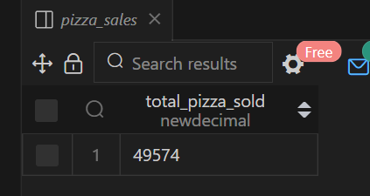

* *Total number of orders :*

SELECT COUNT(DISTINCT order_id) as total_orders from pizza_sales;

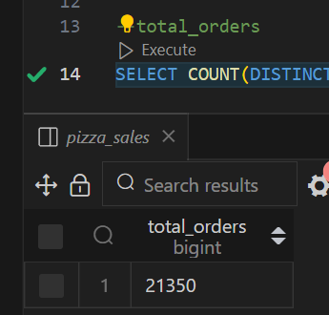

* *Average pizza ordered per order :*

*NOTE : we used the CAST function in this query to find the accurate average (to dodge that the quantity will be floored to the nearest integer)*

* select cast(cast(sum(quantity) as decimal(10,2))/ CAST(COUNT(DISTINCT order_id) as decimal(10,2))
* as decimal (10,2)) as avg_pizza_per_order FROM pizza_sales ;

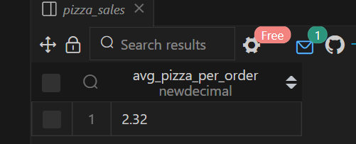

***“From here we will start our calculation used to draw charts on power bi”***

* *Daily trend (amount sold per each day:*
* *We used the dayname function to extract the name of the day from the date column (make sure that the date column is in the right format)*
* *As we can see the most active days are (Friday-Thursday-Saturday) which are holidays in the client country*
* SELECT DAYNAME(order_date) as 'day' , COUNT(distinct order_id) as daily_total_orders FROM pizza_sales
* GROUP BY DAYNAME(order_date);

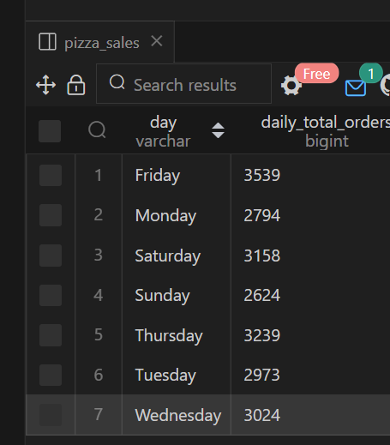

*Monthly trend:*

*As we can see that the sales of the store per month is close and that means that his business is not seasonal and doesn’t depend on seasonal activities*

SELECT MONTHNAME(order_date) as 'month' , COUNT(DISTINCT order_id) as Monthly_trend

FROM pizza_sales

group by MONTHNAME(order_date)

order BY Monthly_trend desc;

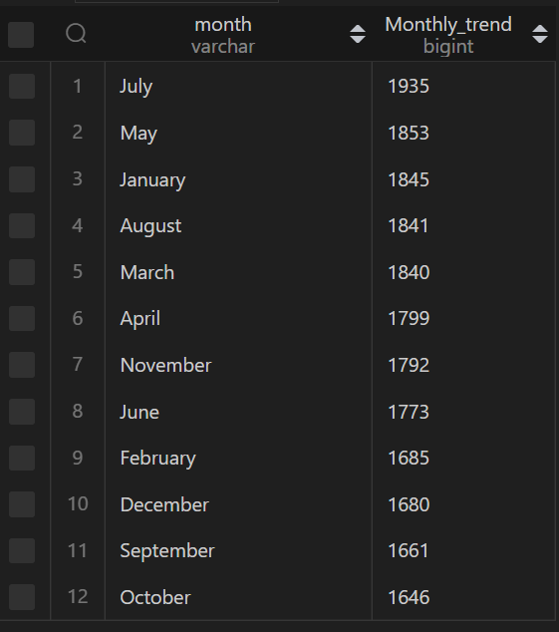

*Rush hours :*

*These are the hours that a rush is occuring so we have to sort them from the rushest hour*

*The rushest 3 hours are 12,1,6 pm which makes sense as those are times of lunch and dinner*

SELECT HOUR(order_time) as "hour" , COUNT(DISTINCT order_id) as orders_per_hour

from pizza_sales

group by HOUR(order_time)

order by orders_per_hour desc;

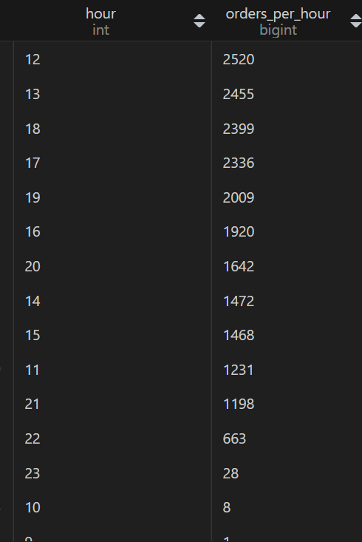

* *Percentage of sales per category:*

*Here we calculated the percentage of sales based on each category they sell in the store*

SELECT pizza_category , cast(SUM(total_price)*100 / (SELECT sum(total_price) from pizza_sales)as decimal(10,2))

as percentage_sales

FROM pizza_sales

group BY pizza_category;

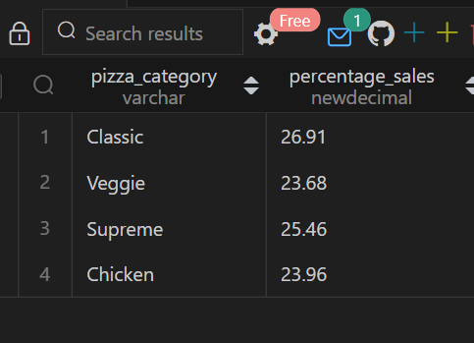

* *Percentage of sales per pizza name:*

SELECT  pizza_name , CAST(SUM(total_price)*100/ (SELECT sum(total_price)

from pizza_sales)as DECIMAL(10,2)) as percentage_sales

FROM pizza_sales;

group BY pizza_name;

* 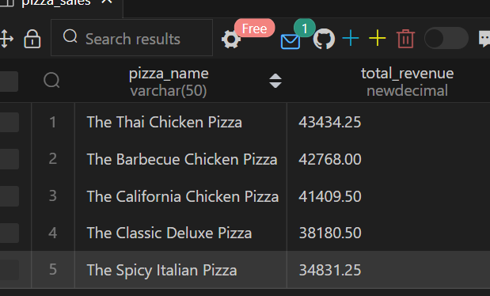;
* *Percentage of sales over pizza size:*

SELECT  pizza_size , CAST(SUM(total_price)*100/ (SELECT sum(total_price)

from pizza_sales)as DECIMAL(10,2)) as percentage_sales

FROM pizza_sales

group BY pizza_size;

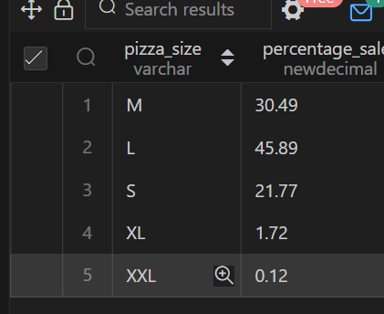

* *top 5 pizza per revenue and lowest 5:*

*here we used the function limit to determine only the top 5 and the lowest 5*

*--note that you only need to change the order by from asc to desc to determine the top 5*

SELECT pizza_name , cast(sum(total_price) as decimal(10,2)) as total_revenue FROM pizza_sales

group by pizza_name

order by total_revenue asc

limit 5;

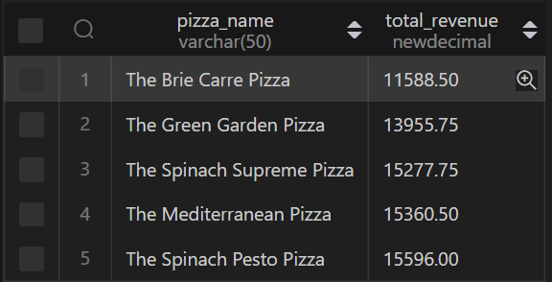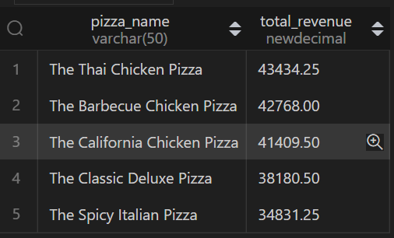

* Top and lowest 5 per quantity ordered:

SELECT pizza_name , count(distinct order_id) as total_orders FROM pizza_sales

group by pizza_name

order by total_orders asc

limit 5;

